Photograph and Videos: Still Photograph
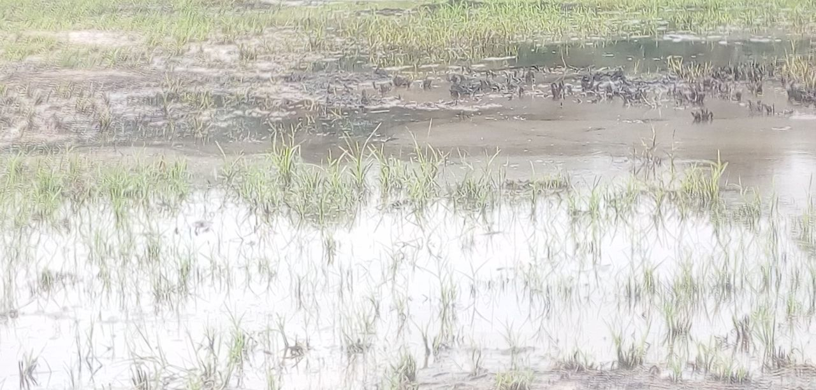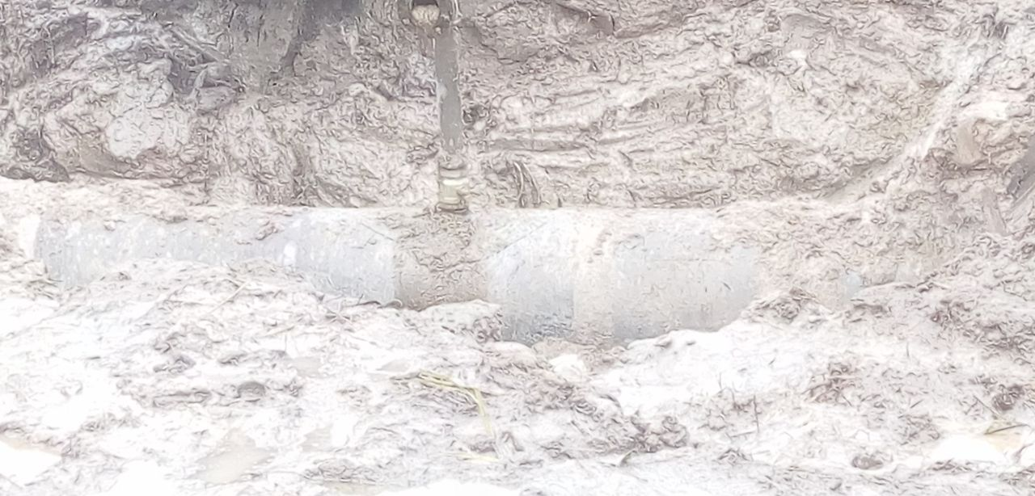
Figure 1: Arrow showing initial status of the Site Figure 2: Arrow showing Spill point
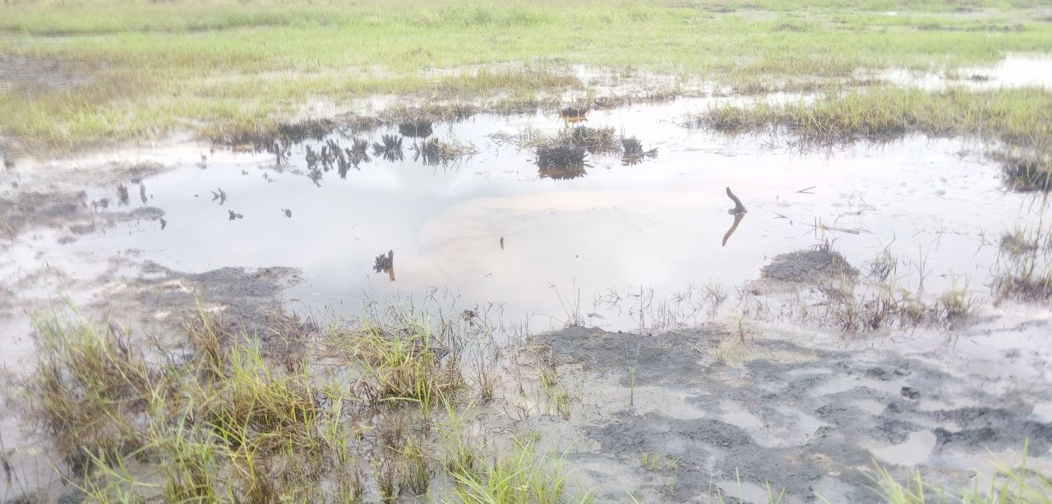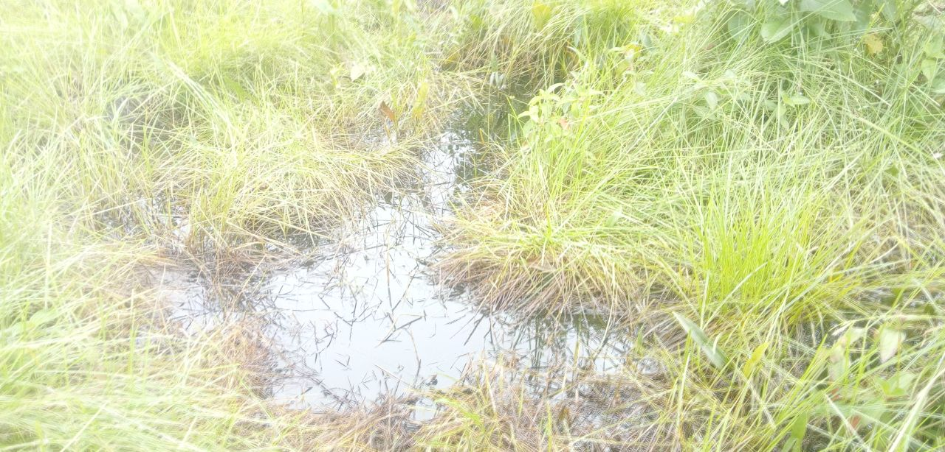
Figure 3: Arrow showing Impacted Area

